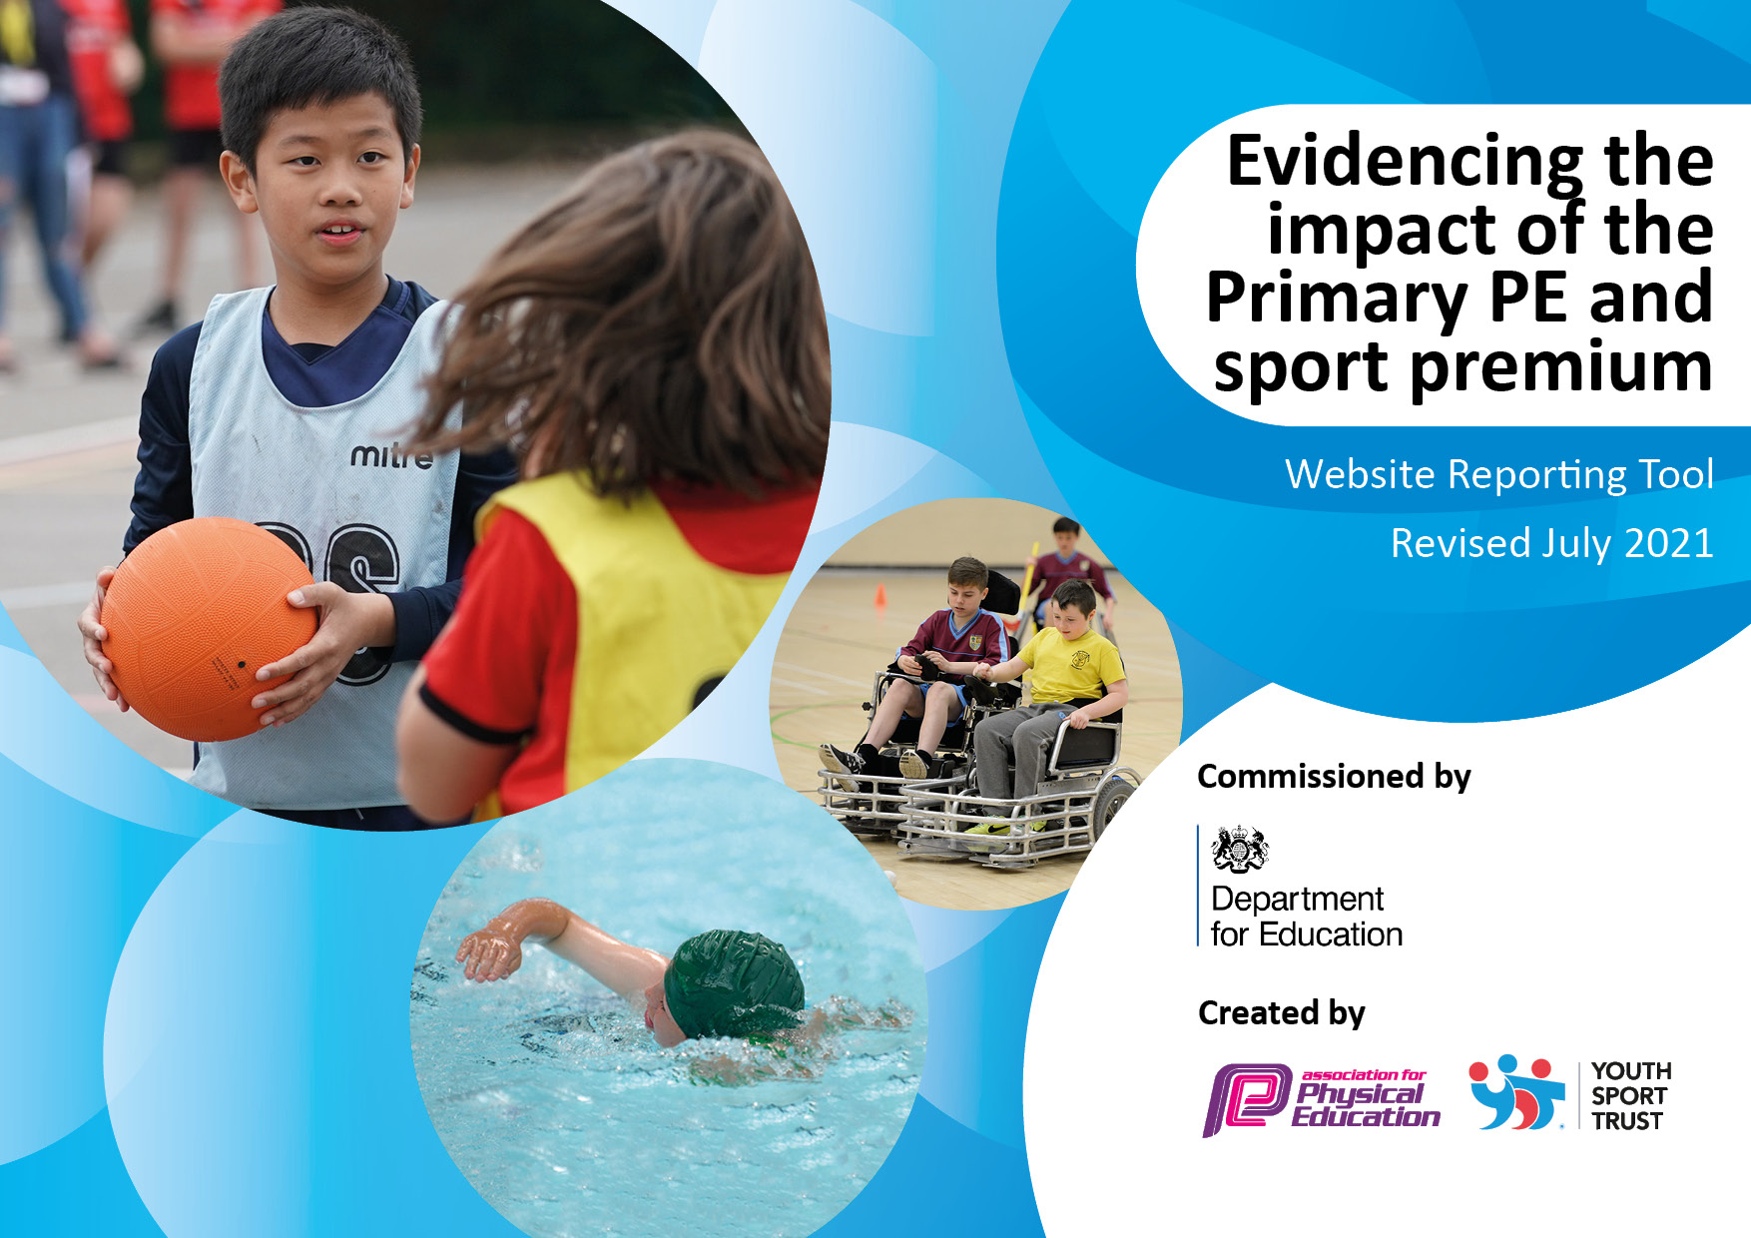
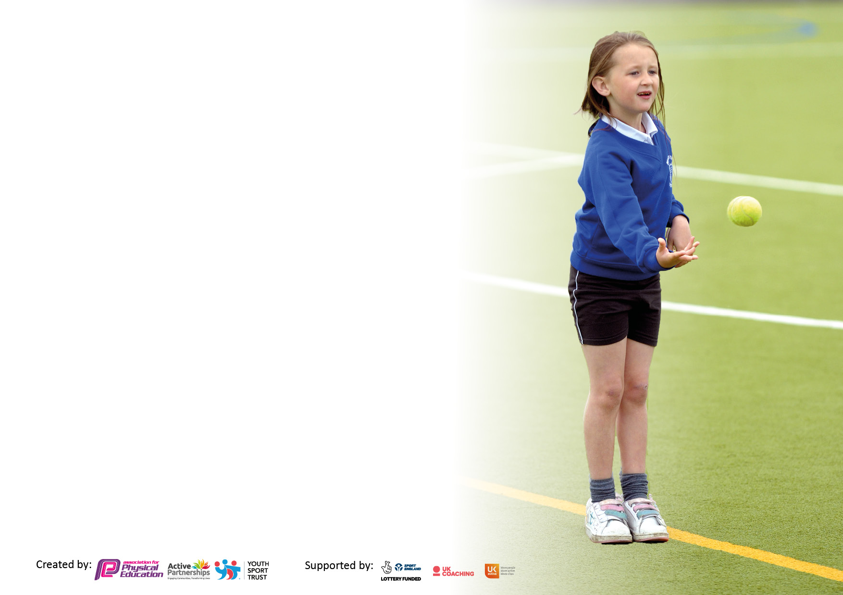

It is important that your grant is used effectively and based on school need. The Education Inspection Framework makes clear there will be a focus on ‘whether leaders and those responsible for governors all understand their respective roles and perform these in a way that enhances the effectiveness of the school’.

Under the Quality of Education Ofsted inspectors consider:
Intent - Curriculum design, coverage and appropriateness
Implementation - Curriculum delivery, Teaching (pedagogy) and Assessment
Impact - Attainment and progress

To assist schools with common transferable language this template has been developed to utilise the same three headings which should make your plans easily transferable between working documents.

Schools must use the funding to make additional and sustainable improvements to the quality of Physical Education, School Sport and Physical Activity (PESSPA) they offer. This means that you should use the Primary PE and sport premium to:

- Develop or add to the PESSPA activities that your school already offer
- Build capacity and capability within the school to ensure that improvements made now will benefit pupils joining the school in future years
- The Primary PE and sport premium should not be used to fund capital spend projects; the school’s budget should fund these.

Please visit gov.uk for the revised DfE guidance including the 5 key indicators across which schools should demonstrate an improvement. This document will help you to review your provision and to report your spend. DfE encourages schools to use this template as an effective way of meeting the reporting requirements of the Primary PE and sport premium.
We recommend you start by reflecting on the impact of current provision and reviewing the previous spend.

Schools are required to publish details of how they spend this funding, including any under-spend from 2019/2020, as well as on the impact it has on pupils’ PE and sport participation and attainment. All funding must be spent by 31st July 2022.

We recommend regularly updating the table and publishing it on your website throughout the year. This evidences your ongoing self-evaluation of how you are using the funding to secure maximum, sustainable impact. Final copy must be posted on your website by the end of the academic year and no later than the 31st July 2021. To see an example of how to complete the table please click HERE.

Details with regard to funding
Please complete the table below.

Total amount allocated for 2022/23 | £17,660
Total amount of funding for 2022/23. To be spent and reported on by 31st July 2023. | £17,660
Swimming Data
Please report on your Swimming Data below.

Meeting national curriculum requirements for swimming and water safety.

N.B. Complete this section to your best ability. For example you might have practised safe self-rescue techniques on dry land which you can then transfer to the pool when school swimming restarts.
Due to exceptional circumstances priority should be given to ensuring that pupils can perform safe self rescue even if they do not fully meet the first two requirements of the NC programme of study
What percentage of your current Year 6 cohort swim competently, confidently and proficiently over a distance of at least 25 metres?  N.B. Even though your pupils may swim in another year please report on their attainment on leaving primary school at the end of the summer term 2020.  Please see note above | 90%
What percentage of your current Year 6 cohort use a range of strokes effectively [for example, front crawl, backstroke and breaststroke]?  Please see note above | 90%
What percentage of your current Year 6 cohort perform safe self-rescue in different water-based situations? | 90%
Schools can choose to use the Primary PE and sport premium to provide additional provision for swimming but this must be for activity over and above the national curriculum requirements. Have you used it in this way? | No

Action Plan and Budget Tracking
Capture your intended annual spend against the 5 key indicators. Clarify the success criteria and evidence of impact that you intend to measure to evaluate for pupils today and for the future.

Academic Year: 2022/23 | Total fund allocated: £17,660 | Date Updated: July 2022
Key indicator 1: The engagement of all pupils in regular physical activity – Chief Medical Officers guidelines recommend that primary school pupils undertake at least 30 minutes of physical activity a day in school |  |  |  | Percentage of total allocation:
 |  |  |  | %
Intent | Implementation |  | Impact
Your school focus should be clear what you want the pupils to know and be able to do and about  what they need to learn and to  consolidate through practice: | Make sure your actions to achieve are linked to your intentions: | Funding allocated: | Evidence of impact: what do pupils now know and what can they now do? What has changed?: | Sustainability and suggested next steps:
Increase numbers of pupils voluntarily taking part in physical activity at lunch and break times.  Provide a wider range of after school sports clubs/widen children’s experiences.  All children to be able to ride a bike by end of Year 6  Promote active travel to school  Swimming ‘Catch-Up’ | Continued lease of field to provide safe and secure area for children to play  Provision of Playpod equipment at break and lunchtimes  Provision and support for nurture group at lunchtimes  Karate/gymnastics after school clubs  Off the Wall Squash  Balanceability Cycling  Bikeability  Have set up ‘Park and Stride’ this year – need to develop further in year ahead.  Year 5 pupils will attend swimming sessions but would like to build capacity to send Year 6s that did not reach standard required. | £1,625 rental and maintenance  £850  £5,625  £300  £1,500  £1,700  £565  £350 | Increased sport participation at lunch/breaks - fewer injuries  Improving numbers at after school clubs - from 100 children to 154 in summer term.  Play interactively and safely with their peers. Have developed the skills to play actively and safely.  High level provision of PE sessions to be monitored and delivered.  Pupil Premium children taking part in all after school clubs.  Provision of sports that may not be traditionally presented to primary children/encourage girls into sport  Improved pass rate at Bikeability at end of Year 6  Increased percentages of Y6 leavers being able to swim | Improved participation in out of school/local sports clubs – baseline taken May 2021.  Safe, active playtimes for all.  High level provision of a variety of PE sessions, developing children’s physical literacy.  Staff CPD on delivery of sessions  Application made to swimming provider to increase numbers at swimming sessions  Local pools to inform school when free sessions available so that parents can be informed.
Key indicator 2: The profile of PESSPA being raised across the school as a tool for whole school improvement |  |  |  | Percentage of total allocation:
 |  |  |  | %
Intent | Implementation |  | Impact
Your school focus should be clear what you want the pupils to know and be able to do and about  what they need to learn and to  consolidate through practice: | Make sure your actions to achieve are linked to your intentions: | Funding allocated: | Evidence of impact: what do pupils now know and what can they now do? What has changed?: | Sustainability and suggested next steps:
Continued and increasing participation in SGO organised events | Gaining support from SGO to develop skills and sports offered. | £200 | Competitions entered increased by 100% increasing resilience and enjoyment of children in sports events. | Continuing increase in competitive competition by creating inter-school competitions with local schools (Pot Kiln Football)

Key indicator 3: Increased confidence, knowledge and skills of all staff in teaching PE and sport |  |  |  | Percentage of total allocation:
 |  |  |  | %
Intent | Implementation |  | Impact
Your school focus should be clear | Make sure your actions to | Funding | Evidence of impact: what do | Sustainability and suggested
what you want the pupils to know | achieve are linked to your | allocated: | pupils now know and what | next steps:
and be able to do and about | intentions: |  | can they now do? What has
what they need to learn and to |  |  | changed?:
consolidate through practice:
To secure high quality PE provision for all pupils through continued monitoring and evaluation of PE.  Carry on pointing staff to available on-line CPD opportunities – particularly OAA training | PE Hub bought to provide well-planned, easy to follow lessons with clear progression.  Ensure PE cupboard well-resourced to enable well-delivered and varied lessons.  Staff to watch delivery of squash sessions to develop their own CPD. Off-the Wall to provide scheme of work for Lower Years and skills certificates.  Research OAA training for staff to add to our curriculum to promote resilience and perseverance. | £375  £620  £900 | ALL children enjoying PE as monitored in pupil perception survey  Teachers feeling confident in their delivery as monitored in Staff perception survey.  Increased pupil resilience and perseverance.  Gaining experience of new outdoor skills including orienteering | Continue to develop staff’s confidence and competence in delivering active, high quality PE lessons.  Continue to point staff in direction of available CPD – whole school CPD to be investigated.  Develop current orienteering provision around school. Ensure all year groups experience an OAA day/series of sessions
Key indicator 4: Broader experience of a range of sports and activities offered to all pupils |  |  |  | Percentage of total allocation:
Intent | Implementation |  | Impact
Your school focus should be clear | Make sure your actions to | Funding | Evidence of impact: what do | Sustainability and suggested
what you want the pupils to know | achieve are linked to your | allocated: | pupils now know and what | next steps:
and be able to do and about | intentions: |  | can they now do? What has
what they need to learn and to |  |  | changed?:
consolidate through practice:
Skipping Man  Balanceability  Off the Wall squash  Forest school Provision | Encourage active playtimes through provision of skipping training and ropes (to be used correctly)  Training for EYFS and KS1 staff in use of balance bikes for PE session  Half termly session of Forest School for each Year Group | £400  £2,250 | Children can skip across the school with resulting physical and mental health benefits.  Children can ride a bike before leaving primary school.  Children experience activities that help them develop risk assessment, perseverance, resilience and a love of the outdoors. | Train a member of staff to deliver with currently trained LSA

Key indicator 5: Increased participation in competitive sport |  |  |  | Percentage of total allocation:
 |  |  |  | %
Intent | Implementation |  | Impact
Your school focus should be clear | Make sure your actions to | Funding | Evidence of impact: what do | Sustainability and suggested
what you want the pupils to know | achieve are linked to your | allocated: | pupils now know and what | next steps:
and be able to do and about | intentions: |  | can they now do? What has
what they need to learn and to |  |  | changed?:
consolidate through practice:
To create Sports Council in school that organises inter-house and whole school events  Transport costs to competitions | Participation in inter-school competitions - Y6 vote for Sports Captains who will organise inter-house events  Mini-bus hire to take teams to competitions enabling children to experience inter-school competition | £200  £200 | Sports leaders will run and host inter-house events providing children with opportunities to develop their mental health and skills as well as their physical ones.  Three intra-house competitions ran – children talked of nerves and excitement before. Crucial events to develop resilience and perseverance.  Increased inter-school competition | Aim is to organise 5 inter-house events this coming academic year.

Signed off by
Head Teacher:
Date:
Subject Leader: | Sarah Fairley
Date: | 30/06/22
Governor:
Date:

